**Von Neumann Architecture**

Von Neumann architecture was first published by John von Neumann in 1945.

His computer architecture design consists of a Control Unit, [Arithmetic and Logic Unit](https://www.computerscience.gcse.guru/glossary/arithmetic-logic-unit) ([ALU](https://www.computerscience.gcse.guru/glossary/arithmetic-logic-unit)), Memory Unit, [Registers](https://www.computerscience.gcse.guru/glossary/register) and Inputs/Outputs.

Von Neumann architecture is based on the stored-program computer concept, where instruction data and program data are stored in the same memory.  This design is still used in most computers produced today.

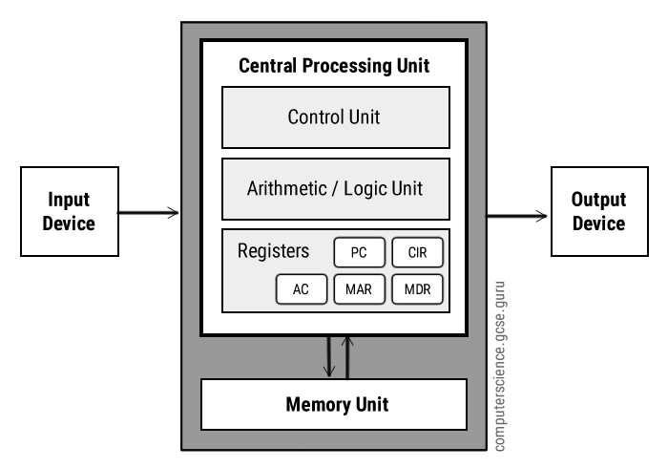

**Central Processing Unit (CPU)**

The [Central Processing Unit](https://www.computerscience.gcse.guru/glossary/central-processing-unit) ([CPU](https://www.computerscience.gcse.guru/glossary/central-processing-unit)) is the electronic circuit responsible for executing the instructions of a computer program.

It is sometimes referred to as the microprocessor or processor.

The CPU contains the ALU, CU and a variety of [registers](https://www.computerscience.gcse.guru/glossary/register).

**Registers**

Registers are high speed storage areas in the CPU.  All data must be stored in a [register](https://www.computerscience.gcse.guru/glossary/register) before it can be processed.

|  |  |  |
| --- | --- | --- |
| [**MAR**](https://www.computerscience.gcse.guru/glossary/memory-address-register) | [Memory Address Register](https://www.computerscience.gcse.guru/glossary/memory-address-register) | Holds the memory location of data that needs to be accessed |
| [**MDR**](https://www.computerscience.gcse.guru/glossary/memory-data-register) | [Memory Data Register](https://www.computerscience.gcse.guru/glossary/memory-data-register) | Holds data that is being transferred to or from memory |
| [**AC**](https://www.computerscience.gcse.guru/glossary/accumulator) | [Accumulator](https://www.computerscience.gcse.guru/glossary/accumulator) | Where intermediate arithmetic and logic results are stored |
| [**PC**](https://www.computerscience.gcse.guru/glossary/program-counter) | [Program Counter](https://www.computerscience.gcse.guru/glossary/program-counter) | Contains the address of the next instruction to be executed |
| [**CIR**](https://www.computerscience.gcse.guru/glossary/current-instruction-register) | [Current Instruction Register](https://www.computerscience.gcse.guru/glossary/current-instruction-register) | Contains the current instruction during processing |

**Arithmetic and Logic Unit (ALU)**

The ALU allows arithmetic (add, subtract etc) and logic (AND, OR, NOT etc) operations to be carried out.

**Control Unit (CU)**

The control unit controls the operation of the computer’s ALU, memory and input/[output devices](https://www.computerscience.gcse.guru/glossary/output-devices), telling them how to respond to the program instructions it has just read and interpreted from the memory unit.

The control unit also provides the timing and control signals required by other computer components.

**Buses**

[Buses](https://www.computerscience.gcse.guru/glossary/bus) are the means by which data is transmitted from one part of a computer to another, connecting all major internal components to the CPU and memory.

A standard CPU system [bus](https://www.computerscience.gcse.guru/glossary/bus) is comprised of a [control bus](https://www.computerscience.gcse.guru/glossary/control-bus), [data bus](https://www.computerscience.gcse.guru/glossary/data-bus) and [address bus](https://www.computerscience.gcse.guru/glossary/address-bus).

|  |  |
| --- | --- |
| [**Address Bus**](https://www.computerscience.gcse.guru/glossary/address-bus) | Carries the addresses of data (but not the data) between the processor and memory |
| [**Data Bus**](https://www.computerscience.gcse.guru/glossary/data-bus) | Carries data between the processor, the memory unit and the input/output devices |
| [**Control Bus**](https://www.computerscience.gcse.guru/glossary/control-bus) | Carries control signals/commands from the CPU (and status signals from other devices) in order to control and coordinate all the activities within the computer |

**Memory Unit**

The memory unit consists of [RAM](https://www.computerscience.gcse.guru/glossary/random-access-memory), sometimes referred to as primary or main memory.  Unlike a hard drive (secondary memory), this memory is fast and also directly accessible by the CPU.

RAM is split into partitions.  Each partition consists of an address and its contents (both in [binary](https://www.computerscience.gcse.guru/glossary/binary) form).

The address will uniquely identify every location in the memory.

Loading data from permanent memory (hard drive), into the faster and directly accessible temporary memory (RAM), allows the CPU to operate much quicker.